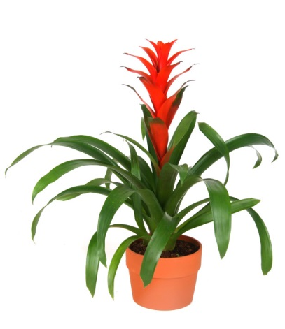
Plant Kingdom Overview NOTES
- Major characteristics of ALL plants…
- Prokaryotic (nucleus)
- Multicellular
- Autotrophic
- No locomotion
- Cell wall made of cellulose

- SOME plants, however…
- Have NO roots, stems, or leaves (ex. Mosses, algae), so they need to live in a moist/wet environment
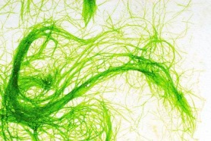
- Have NO flower ,fruit or seeds, so they reproduce using spores, instead

- Plants that HAVE roots, stems, and leaves are called vascular plants. They have vessels/tubes to carry food and water throughout their bodies. Most have either flowers (seeds) or cones (like pine cones) that are used for reproduction. Egg cells become fertilized by plant sperm (called pollen) inside the flower or cone. This is an example of sexual reproduction.

- When the egg cell is fertilized by the pollen, it becomes zygote/fruit. Seed Plants are vascular plants that use seeds for reproduction. They have vascular tissue that is used to transport water and food throughout the plant. There are 2 main types of vascular tissue:

- Xylem – transport water up from the roots to the leaves
- Phloem – transport glucose from the leaves down to the roots

Plant Organs
Organ | Structure | Function
Root | 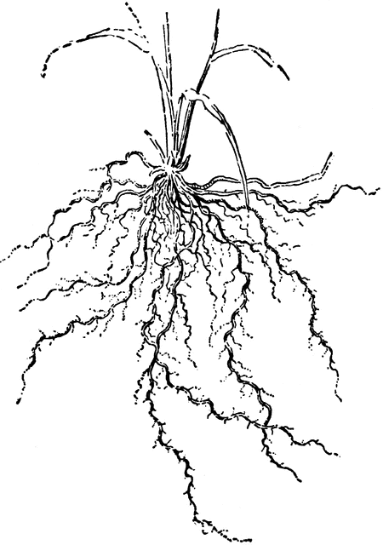  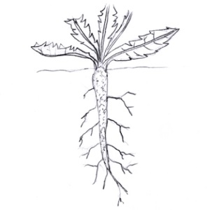 | - Absorbs water and minerals  - Anchors plant  - Stores glucose/starch
Stem | 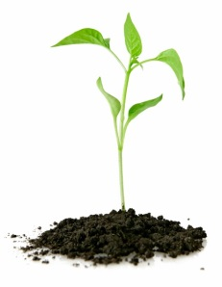  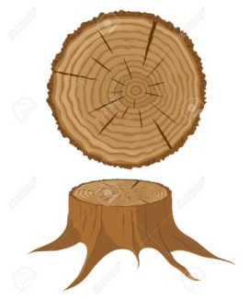 | - Holds leaves up  - Connects roots to leaves  - Stores glucose/starch
Leaf | 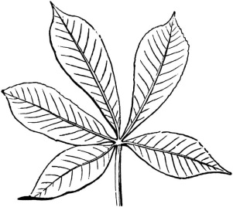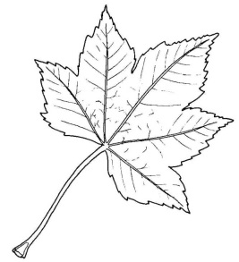 | - Photosynthesis  - Some store glucose/starch
Flower | 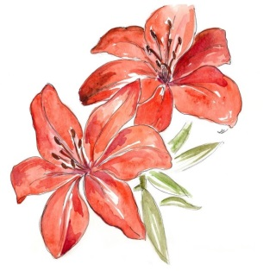 | Sexual reproduction - produces seed
Fruit | 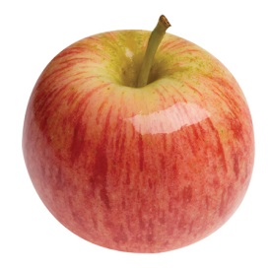 | - Protects the seed  - Helps with seed dispersal
Seed | 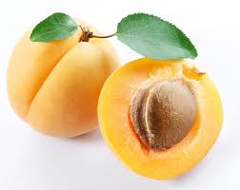 | Produces new plant

